Publisher: Ada Smith

Platform: Unity

System: HTC Vive

The Grab script compliments the Simple Sword equip script. Simple add to Controllers and you are ready to go. You can do this by dragging the script under inspector for Controllers or dragging unto the controllers. It utilizes the grip buttons for this operation since the Simple Sword Equip script utilizes the Trigger Button.

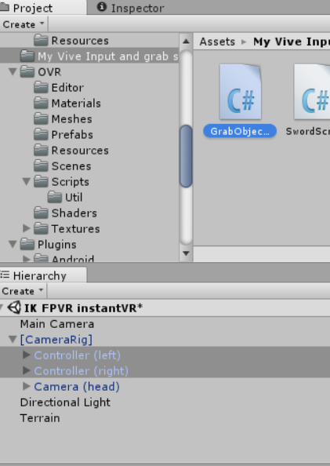

Youtube Video Instructions

https://www.youtube.com/watch?v=jMP5RmUsDAU